

Assertiveness

It is common to hear people say, ‘I am not assertive’. But it is more likely to be true that we can all be more or less assertive at diﬀerent times, in diﬀerent situations and with diﬀerent people.

Completed example

I am more assertive when: |  | I can lack assertiveness when:
 | Reminding people - | 
Challenging micro- | again - that I can’t | Challenging micro-
Challenging micro- | attend in-person | Challenging micro-
aggressions in | attend in-person | aggressions from
aggressions in | meetings at short notice | aggressions from
team meetings | meetings at short notice | seniors
Saying no to |  | Pushing back on last minute
after work drinks |  | requests that mean working
 |  | into the evenings

Use the scaling tool below to map times when you have been more assertive than others. Then ask yourself:

- What was happening when it felt easier?

- Do these instances have anything in common?

- What can I learn from those instances?

- Am I more or less likely to be assertive in the moment or do I prefer to prepare for an assertive conversation?

- Is it easier for me to be more assertive on behalf others? With friends/family? With team members/peers? With seniors?

- Is it easier or harder for me to be assertive when asking for support with my disability or long-term health condition?

Rating my assertiveness
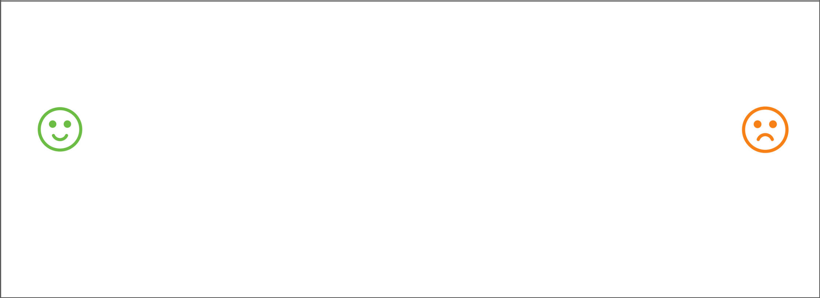

I am more | I can lack
assertive | assertiveness
when: | when:


Helpful language

Start sentences with ‘I’: I need, I feel, I heard, I will, I believe

When you… (give specific example) I feel…

The impact on me/others is…

What I need… (describe the behaviour you want or need)

I understand… / I appreciate… (acknowledge their position)

What’s a win/win (or compromise) here? Can we agree to…?

Unhelpful language

You always… you never (avoid generalisations)

Why don’t you…? (why can cause people to become defensive)

This is really hard / It’s not ok

I’m sorry, but… / I don’t mind / Whatever you think.

Could you… / Do you think you might… / Is it ok if…

You need to… / I need you to…

