

Asking for our needs to be met

Assertive communication acts as a bridge between ourselves and others. This can be more or less challenging, dependent on two factors:

- how clear I am about my needs

- others’ awareness/knowledge/experience.

HIGH

OTHERS: awareness/knowledge/exp.

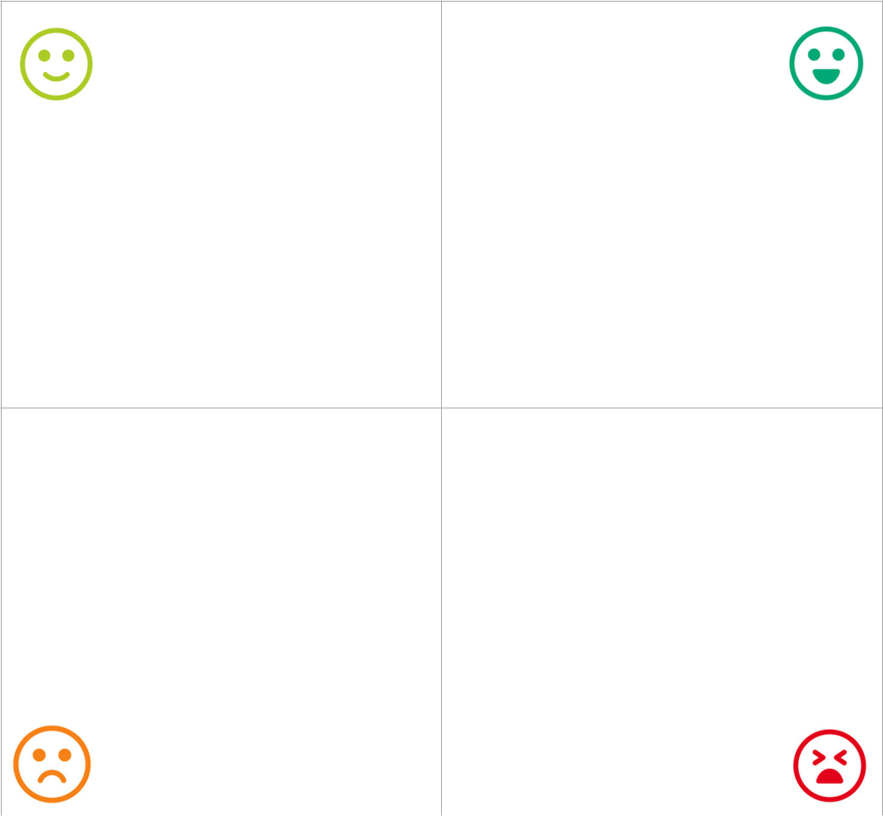

SUPPORT SPOT | SWEET SPOT

STUCK SPOT | SWEAT SPOT
 | SELF: clarity over my needs | HIGH

